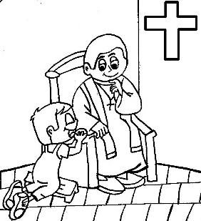
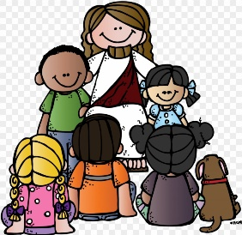
Prayers 2nd Grade

Sign of the Cross  In the name of the Father,  and of the Son,  and of the Holy Spirit. Amen.  Our Father  Our Father, who art in heaven,  hallowed be thy name.  Thy kingdom come,  thy will be done  on earth as it is in heaven.  Give us this day our daily bread  and forgive us our trespasses  as we forgive those who trespass against us;  and lead us not into temptation,  but deliver us from evil. Amen.  Hail Mary  Hail Mary, full of Grace!  The Lord is with thee.  Blessed art thou among women,  and blessed is the fruit of thy womb, Jesus.  Holy Mary, Mother of God,  pray for us sinners  Now and at the hour of our death. Amen.  Glory Be to the Father  Glory be to the Father,  and to the Son,  and to the Holy Spirit.  As it was in the beginning, is now,  and ever shall be,  world without end. Amen. | Act of Contrition (Prayer of Sorrow)  My God,  I am sorry for my sins with all my heart.  In choosing to do wrong and failing to do good,  I have sinned against you  Whom I should love above all things.  I firmly intend, with your help,  to do penance,  to sin no more,  and to avoid whatever leads me to sin.  Our Savior Jesus Christ  suffered and died for us.  In His name. My God have mercy. Amen.  Apostles Creed  I believe in God, the Father Almighty,  Creator of Heaven and earth;  and in Jesus Christ, His only Son Our Lord,  who was conceived by the Holy Spirit,  born of the Virgin Mary,  suffered under Pontius Pilate,  was crucified, died, and was buried.  He descended into hell; on the third day  He rose again from the dead;  He ascended into Heaven,  and is seated at the right hand of God, the Father almighty;  from there He will come to judge the living and the dead.  I believe in the Holy Spirit,  the holy Catholic Church,  the communion of saints,  the forgiveness of sins,  the resurrection of the body  and life everlasting. Amen.

Each child will be receiving his/her First Reconciliation in May.

The children should have a basic understanding of the sacraments.

- What is a sacrament?
A sacrament is a holy sign given to us by Jesus to give us grace.

- What is grace? Grace is the gift of God’s life and love within us through the power of the Holy Spirit.

- What is Baptism? Baptism is the sacrament by which we are welcomed into God’s family, the Church. Through Baptism we become children of God. We are baptized with water. As the priest pours water over our forehead, he says “I baptize you in the name of the Father, and of the Son and of the Holy Spirit.”

- What is Penance, also known as Reconciliation?

- Reconciliation is the sacrament by which, when we are sorry for our sins, we receive God’s forgiveness.

- Confession is telling our sins to the priest.
- The Act of Contrition is our prayer of sorrow for our sins.
- Absolution is the prayer of God’s forgiveness (prayed by the priest).
- Penance is also a prayer or action that shows we are truly sorry for our sins by making reparation (making up) for the sins.

- What is sin? A sin is choosing to do what is wrong or failing to do what is right or good.

Please help your child prepare for this sacrament. (Prayers on reverse side)
The children will need to know and be able to recite the following prayers:

Sign of the Cross Glory be to the Father
Our Father Act of Contrition
Hail Mary Apostles Creed

